**Validated Learning**

We conducted a survey to check the people’s awareness about hydroponics and the currently available hydroponic pods. We also asked a few questions related to our product and all the results are presented below. A total of 126 responses were obtained.

Awareness regarding hydroponics –

* 61.1% of the people did not know about hydroponics.

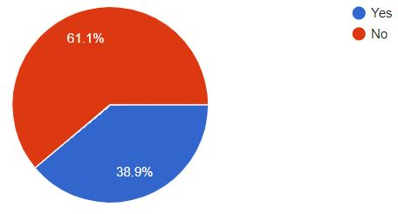

* When asked about the effectiveness of hydroponics over soil farming, 53.2% were doubtful while 9.5% said no.

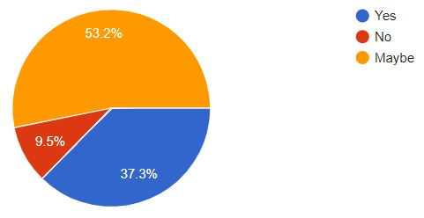

* When asked about the quality of food produced, 46% found it higher with 22.2% finding it lower. 31.7% found the quality of the food same as that grown using soil farming.

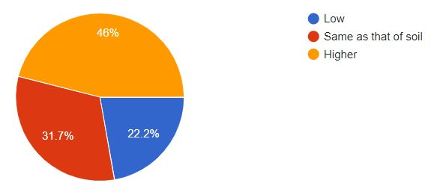

* 45.2% people thought that hydroponics can be used in their area whereas, 34.1% & 20.6% where not sure and did not find it feasible, respectively.
* When given the option of choosing between a soil grown vegetable and a hydroponically grown vegetable, 55.6% preferred soil grown over hydroponics.

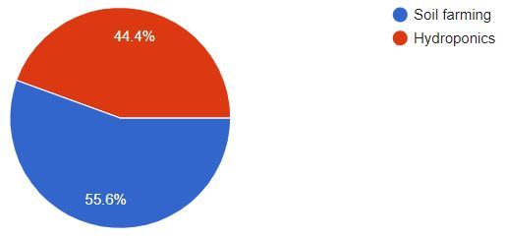

* The same consensus was found regarding the nutritious value of the grown food, with 58.7% people finding soil grown food more nutritious as compared to 41.3% people who found hydroponically grown food more nutritious.

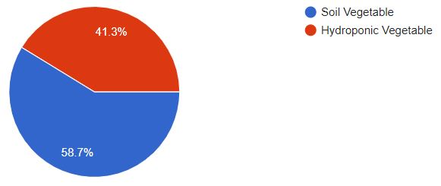

* 68.3% thought of hydroponic food being costlier than normally grown food.

Knowledge about similar products (a picture of a hydroponic pod was shown) –

* Only 23% of people knew about a similar product i.e. a hydroponic pod.
* 39.7% of people showed interest in buying such a product while, 14.3% were not interested and the rest 46% were undecided.

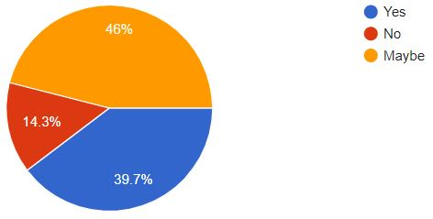

* Only 37.3% of people thought that the quantity produced in the product would be enough for home usage.

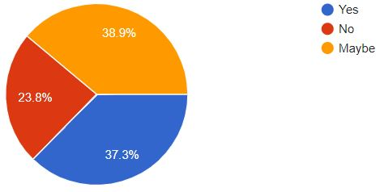

* 52.4% people found the product useful while 36.5% were undecided.

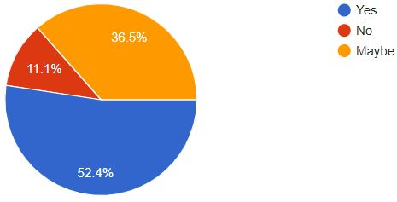

* We also inquired about what the person would use it for. 46% of the people decided to use it for growing vegetables, 21.4% for fruits, 16.7% for flowers while the remaining 15.9% for growing herbs.

Next, we pitched our product and asked a few questions related to it –

* 94.4% of the people showed interest in our product.

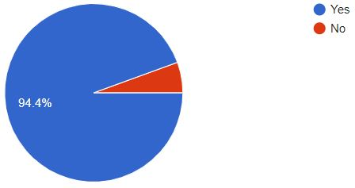

* 43.7% people were interested in buying our product while 41.3% were undecided.

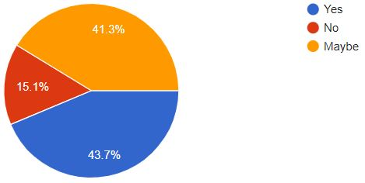

* 48.4% people thought of our product being more useful than the ones currently available in the market while, 42.1% were undecided.

